Process flow for Jira –
- In Backlog section, Create Epic – Browser.
- Click on create issues, Select issue type as Story & start adding all Stories.
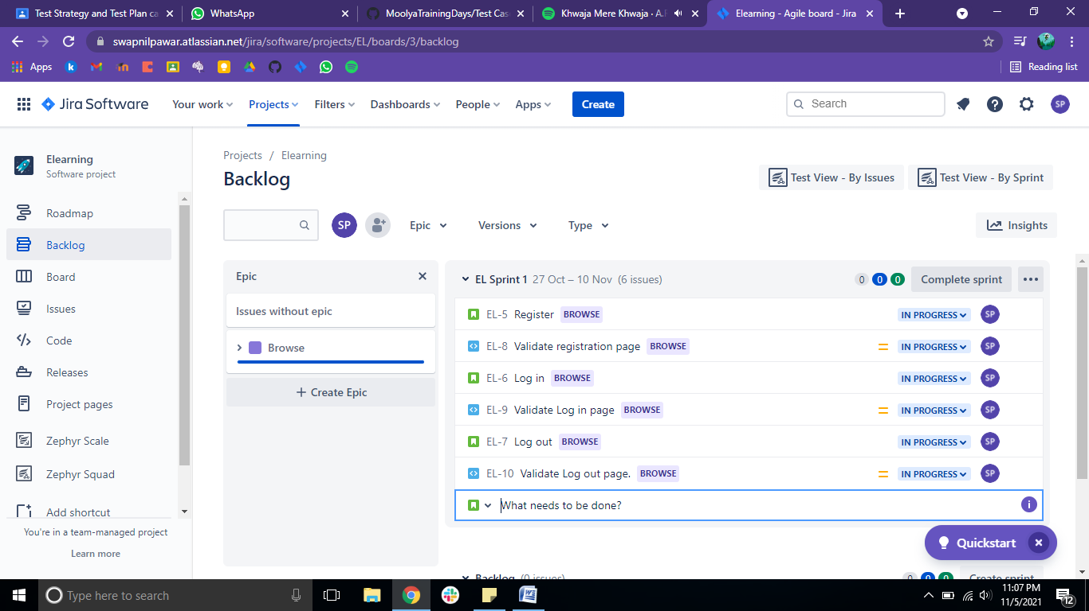

- Drag & drop all stories which are related to Browser epic to the Browser Epic section. This will categories the stories to respective Epic.
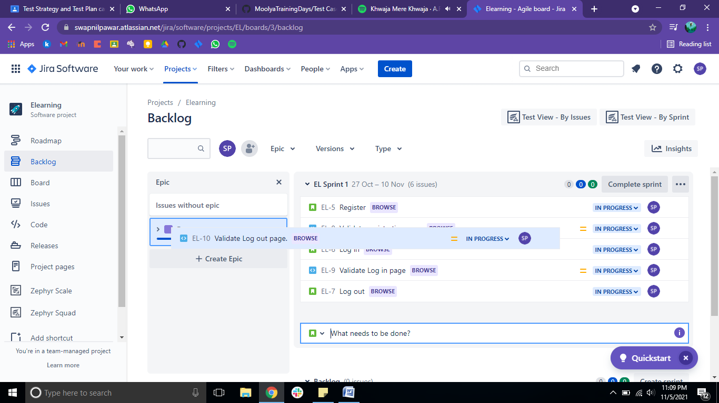

- To create issue type – Test
- Click on project settings – Issue types
- Click on Add issue type – create issue type as a test and click on create.
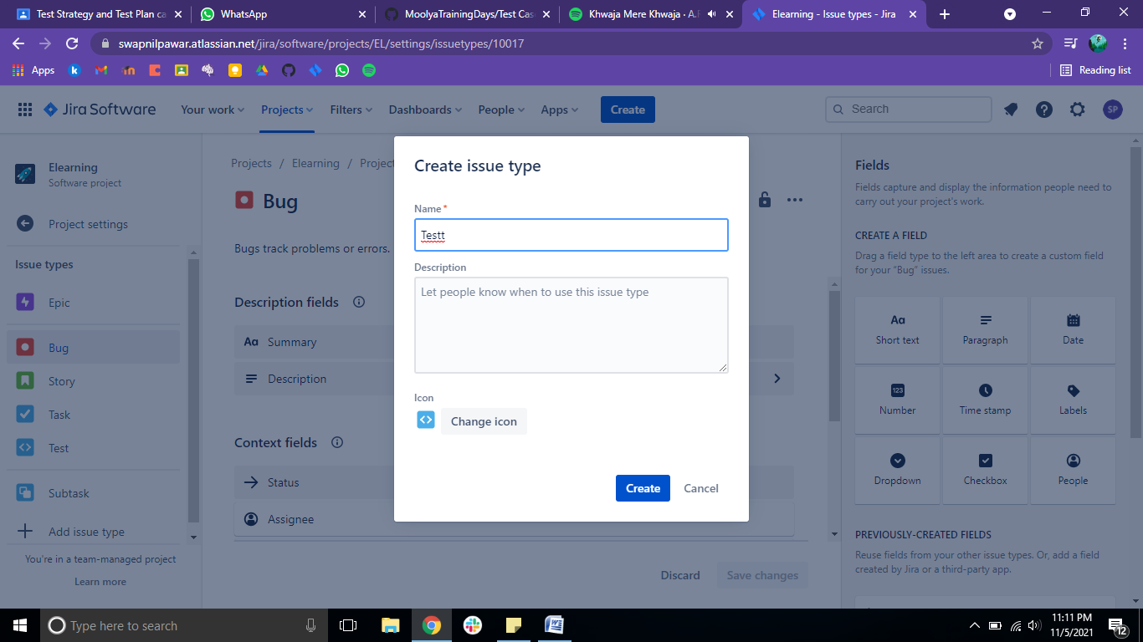

- In Backlog section, Create issues as a test type to validate the all stories.
- Eg – Validate Registration page, Validate Login page, Validate logout page.
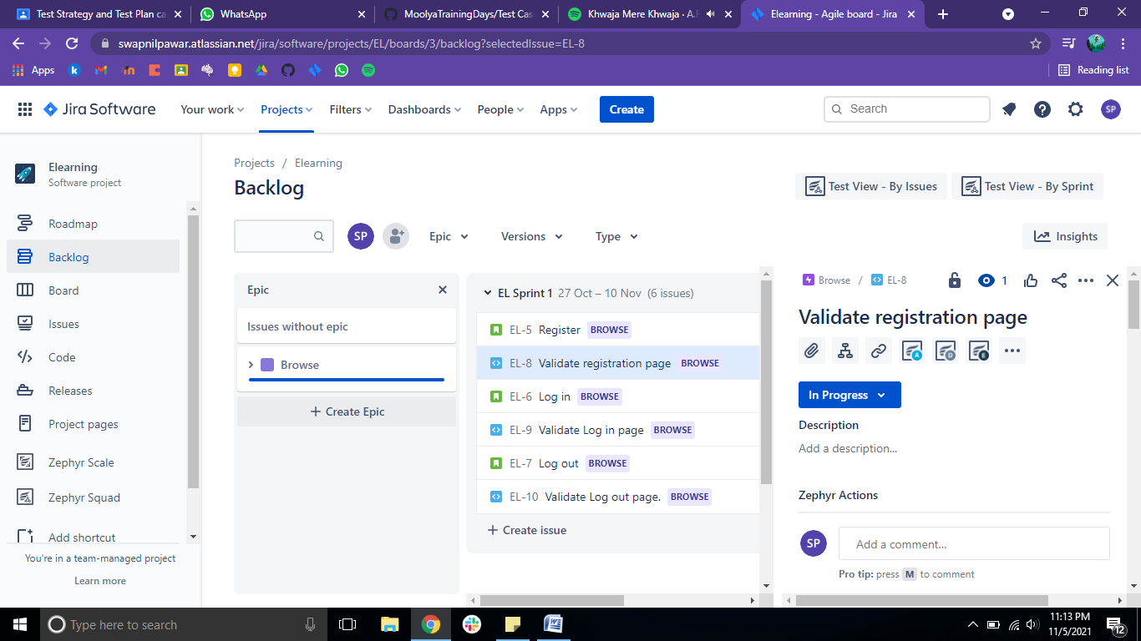

- Sort the all stories & tests in Sprint 1 & respective sprints. And click on Start Sprint 1.
- In board section, this is an Kan Ban, which shows the all activities status like to do, in process, and done. Here we can add user define stages by clicking + right
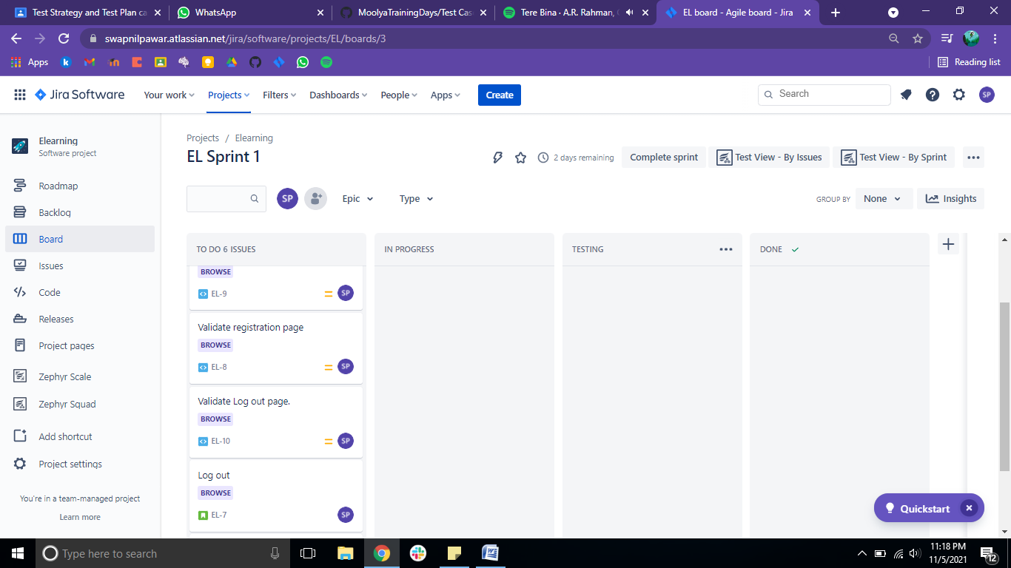

- Drag & drop the stories which we are going to work. This is give idea on the team is now working on this particular Story.

Process flow for Zephyr Scale & Squad –
- Zephyr is not a pre installed tool in Jira. So we need to install this extension in Jira.
To add Zephyr
- Click on Apps – from drop down menu select find new apps – Search for zephyr
- Now click on zephyr Squad and click on get app also same for zephyr scale app.
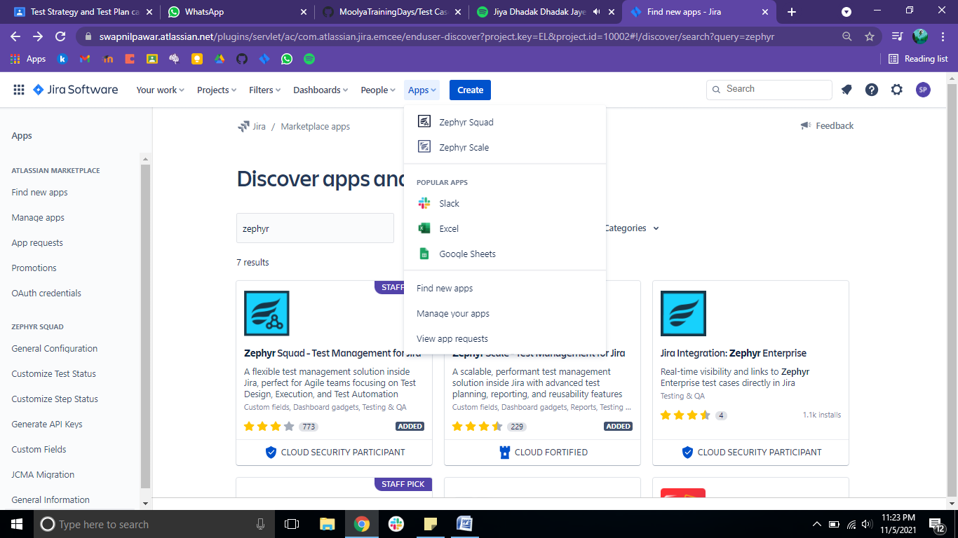

- TO execute the test cases, there is need to create the test cycles.
Steps to create test cycle
- Click on zephyr Squad – then click on cycle summery
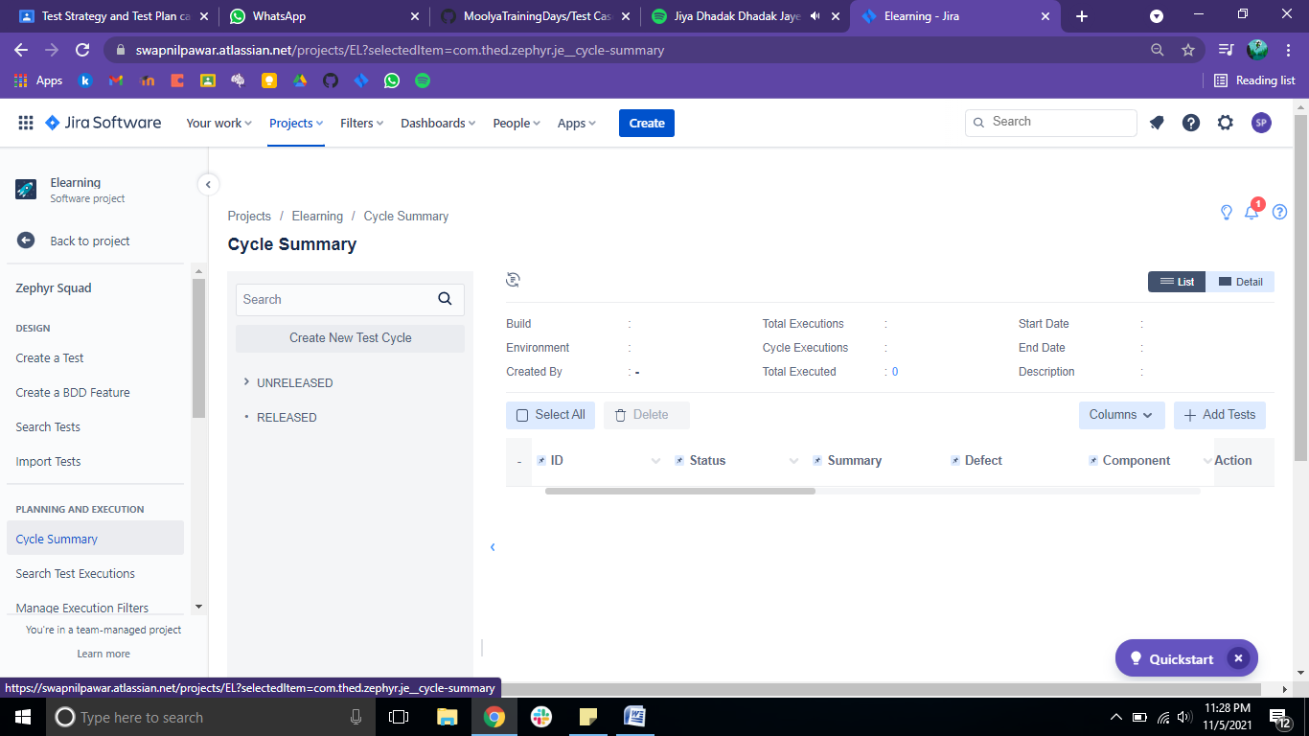

- Now click on ‘Create new test cycle’
- In popup, you can set the version, name for test cycle, Build, test environment, Cycle time in days. After filling all details click on save
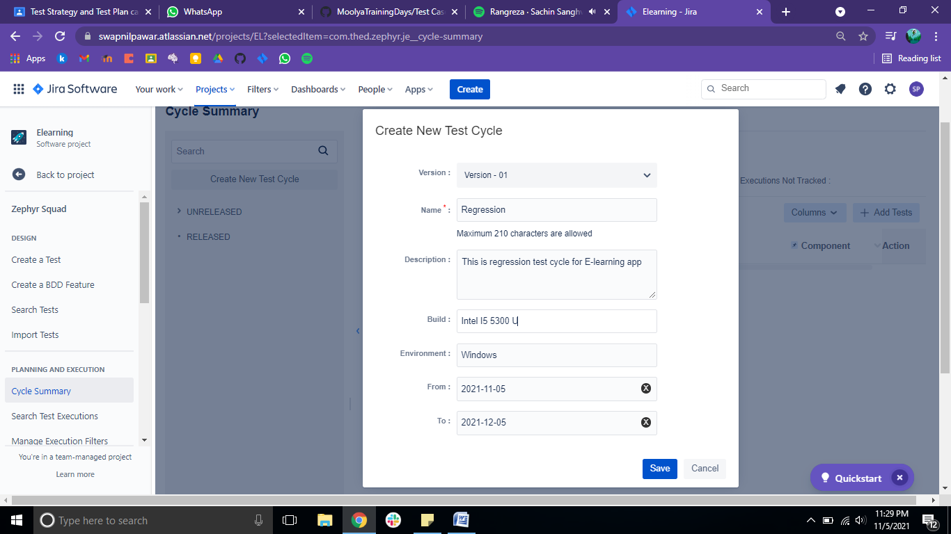

- Creating Test Cases for each story.
- Test case creation flow for registration page
- In backlog section – open ‘Validate registration page’ in new window.
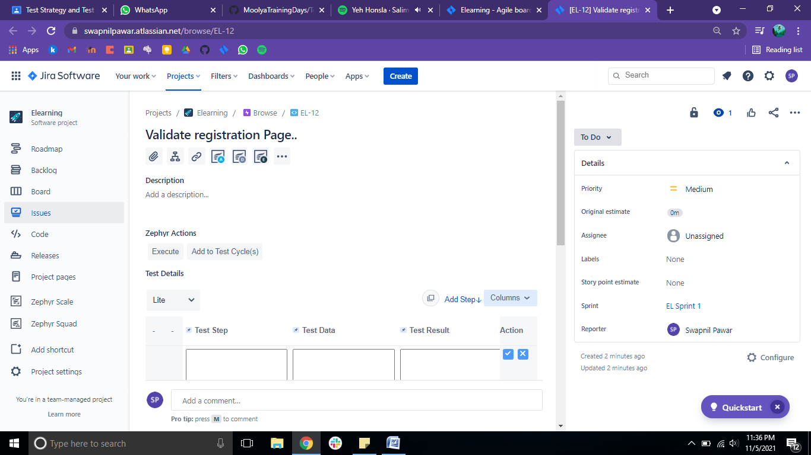

- In test details section add all fills , Test step, Test data, Test result.
Eg –
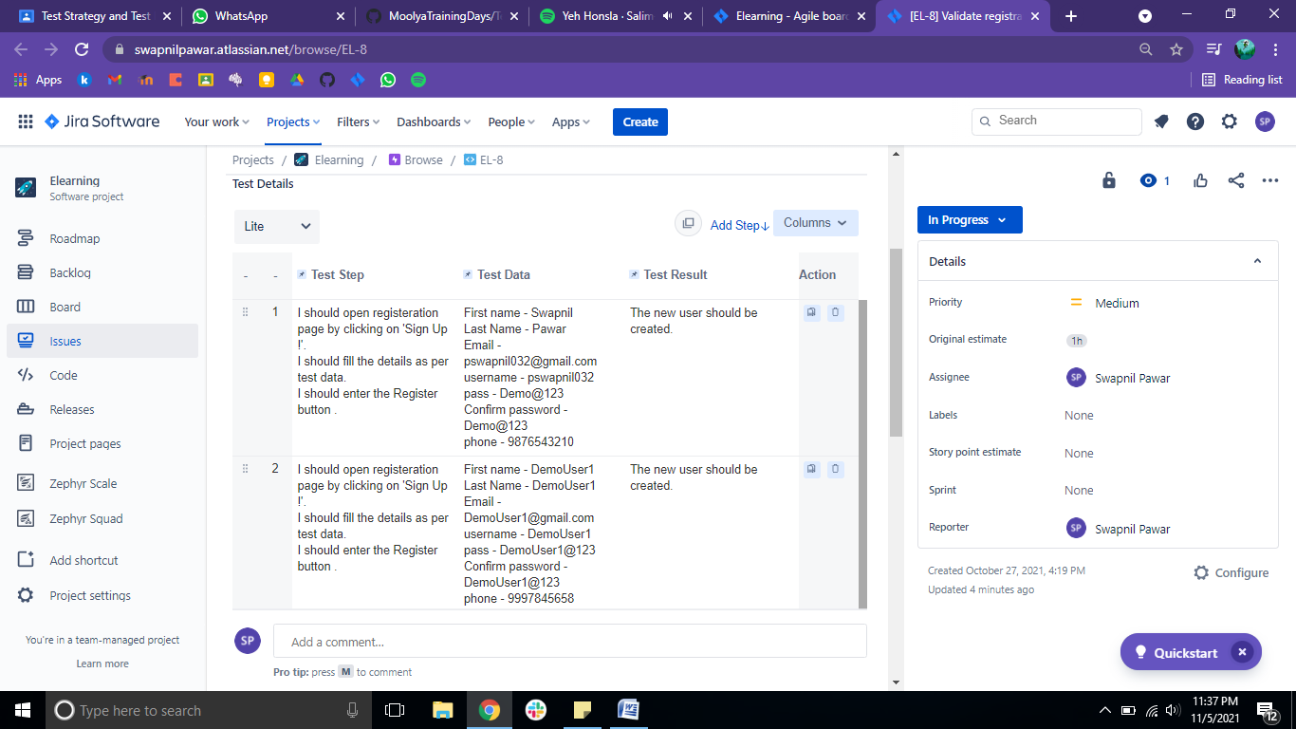

You can add test cases as many as you want.

- Now add these test cases to the particular test cycle by clicking on ‘add to test cycle(s)’.

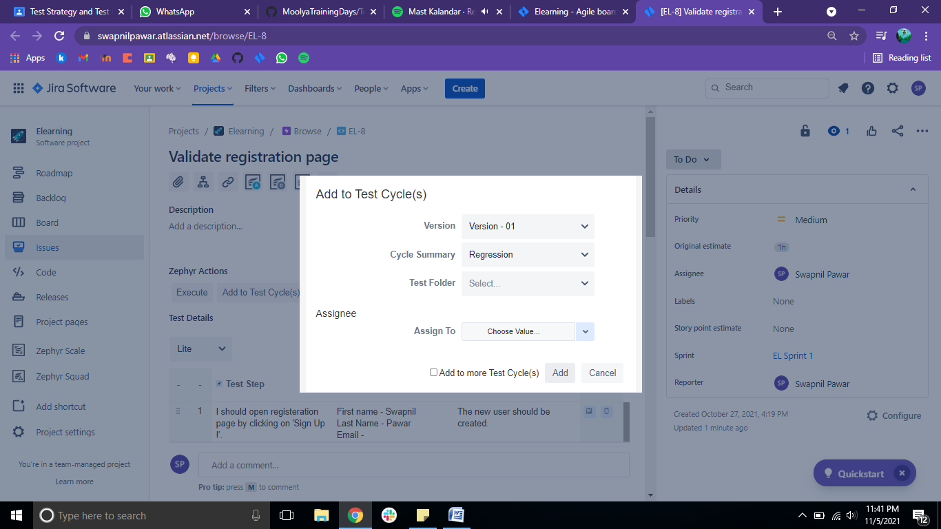

Test Case Execution flow –

For executing test cases click on ‘Execute’ and assign the version, test cycle.
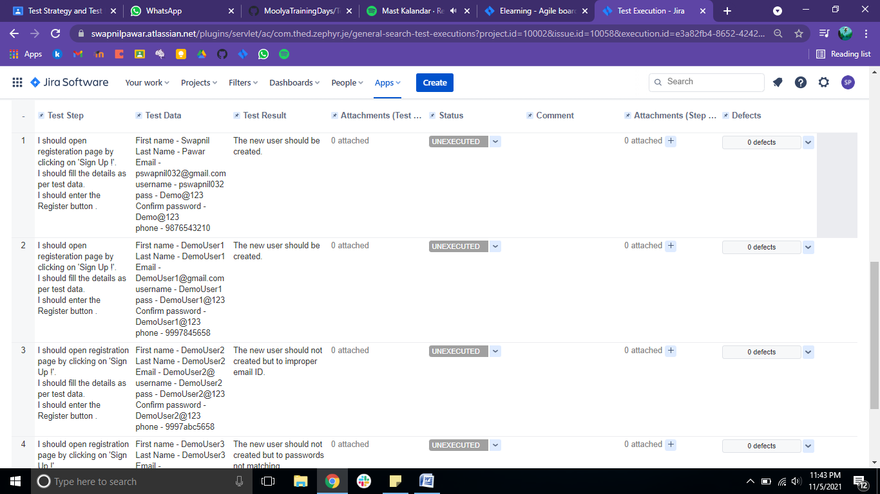

On above slide, all test cases will be shown,
As you execute the each test case on software, change the status to PASS/ FAIL/ WIP/ BLOCKED
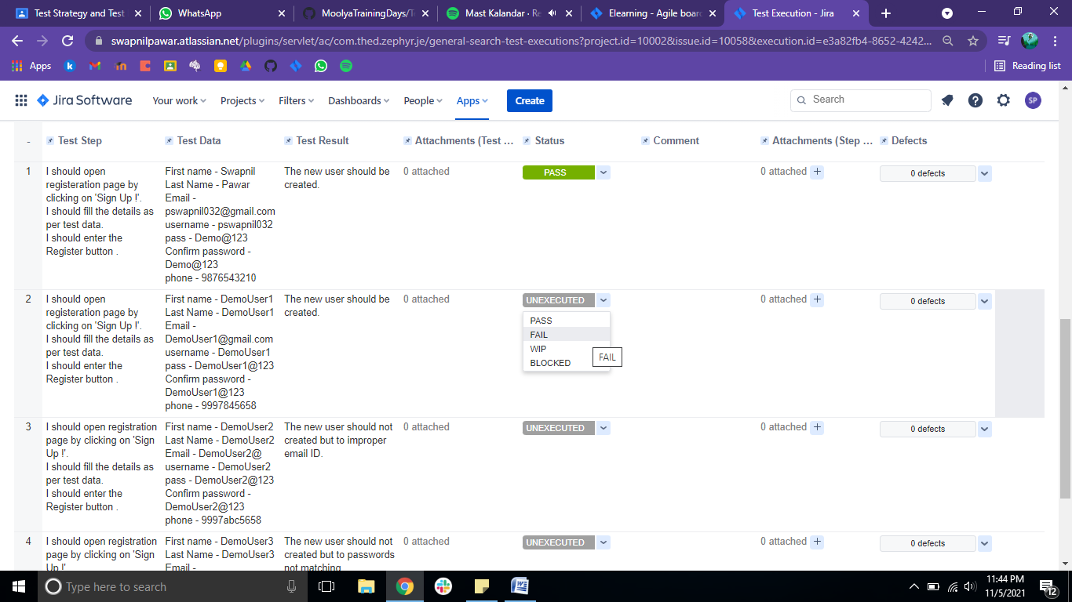

After executing all test cases the popup will be shown to execute the test case. Then click on execute.
Now you can shift this completed test case to the Done section in Kan Ban (Board).

Following is the actual test case execution results on E-learning software.

URL: - http://elearningm1.upskills.in/

EPIC - Browse
Story 1 :- Register
Story 2 :- Login
Story 3 :- Logout

1] Test case flow for Register page-

Test Case - 01:-

Test steps :- i. I should open the registration page by clicking on 'Sign Up !'.
Ii. I should fill in the details as per test data.
Iii. I should enter the Register button .
Test Data :- i. First name - Swapnil
Ii. Last Name - Pawar
Iii. Email - pswapnil032@gmail.com
Iv. username - pswapnil032
v. pass - Demo@123
vi. Confirm password - Demo@123
vii. phone - 9284733571
Test Result :- The new user should be created.

Snapshots :-
1.
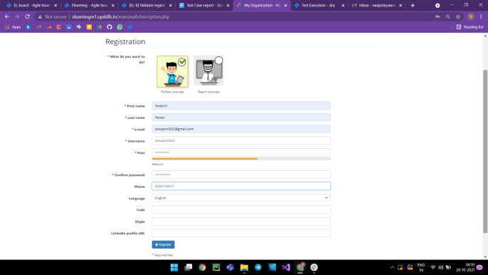
2.
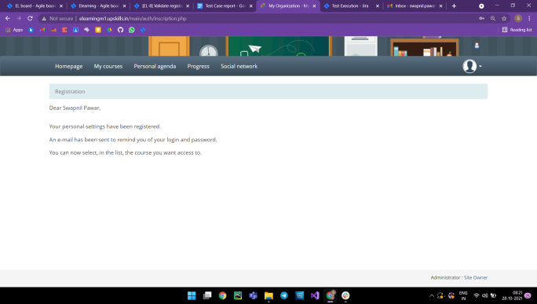
Test Case - 02:-

Test steps :- i. I should open the registration page by clicking on 'Sign Up !'.
Ii. I should fill in the details as per test data.
Iii. I should enter the Register button .
Test Data :- i. First name - DemoUser1
Ii. Last Name - DemoUser1
Iii. Email - DemoUser1@gmail.com
Iv. username - DemoUser1
v. pass - DemoUser1@123
vi. Confirm password - DemoUser1@123
vii. phone - 9997845658
Test Result :- The new user should be created.

Snapshots :-
1.
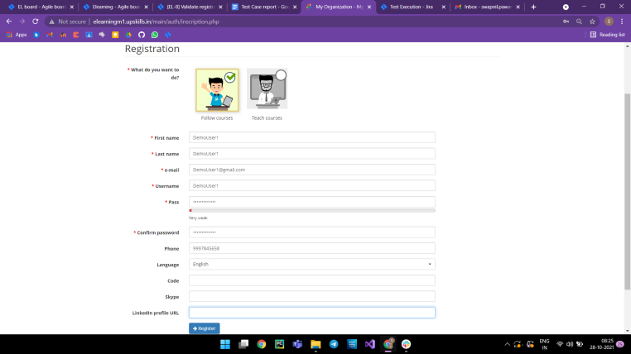

2.
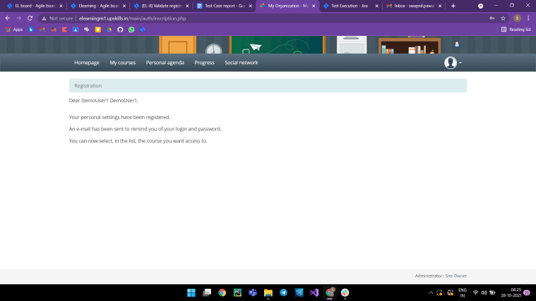

Test Case - 03:-

Test steps :- i. I should open the registration page by clicking on 'Sign Up !'.
Ii. I should fill in the details as per test data.
Iii. I should enter the Register button .
Test Data :- i. First name - DemoUser2
Ii. Last Name - DemoUser2
Iii. Email - DemoUser2@
Iv. username - DemoUser2
v. pass - DemoUser2@123
vi. Confirm password - DemoUser2@123
vii. phone - 9997abc5658
Test Result :- The new user should not be created due to improper email ID.

Snapshots :-
1.
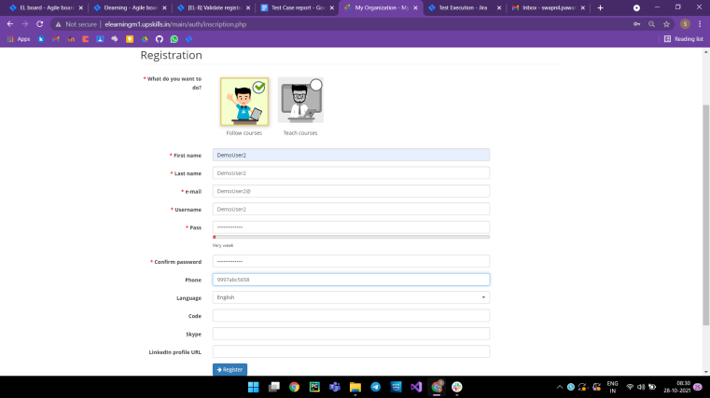

2.
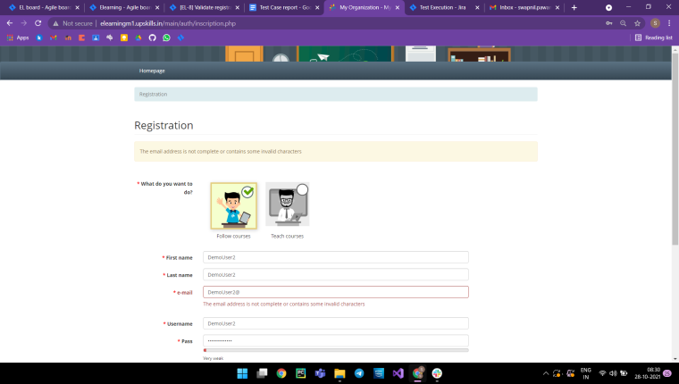

Test Case - 04:-

Test steps :- i. I should open the registration page by clicking on 'Sign Up !'.
Ii. I should fill in the details as per test data.
Iii. I should enter the Register button .
Test Data :- i. First name - DemoUser3
Ii. Last Name - DemoUser3
Iii. Email - DemoUser3@gmail.com
Iv. username - DemoUser3
v. pass - DemoUser3@123
vi. Confirm password - DemoUser2@123
vii. phone - 99976585658
Test Result :- The new user should not be created but to passwords not matching.

Snapshots :-
1.
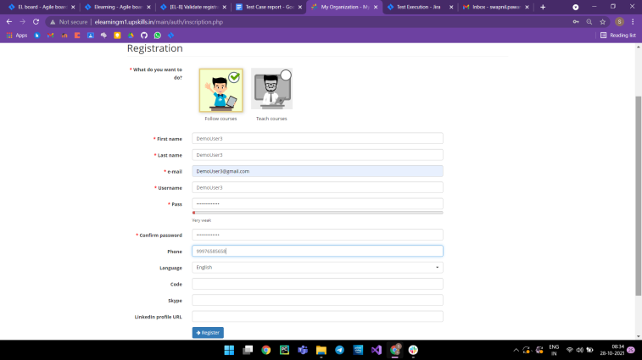

2.
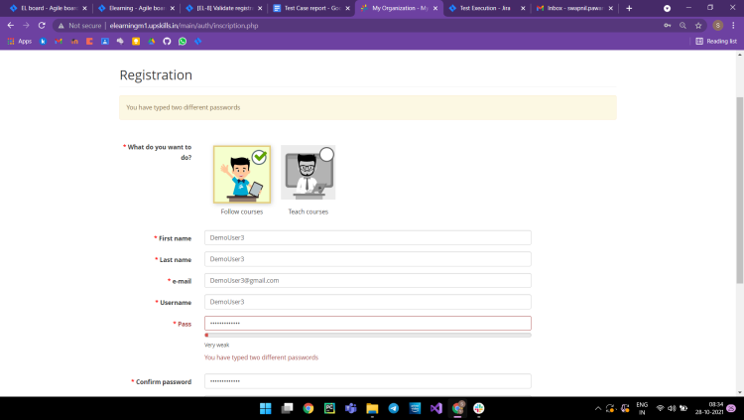

3] Test case flow for Login page-

Test Case - 01:-

Test steps :- i. I should open the login page.
ii. I should fill in the details as per test data.
iii. I should enter the login button.
Test Data :- i. Username :- pswapnil032
Ii. Password :- Demo@123
Test Result :- The My courses page should be open.

Snapshots :-
1.
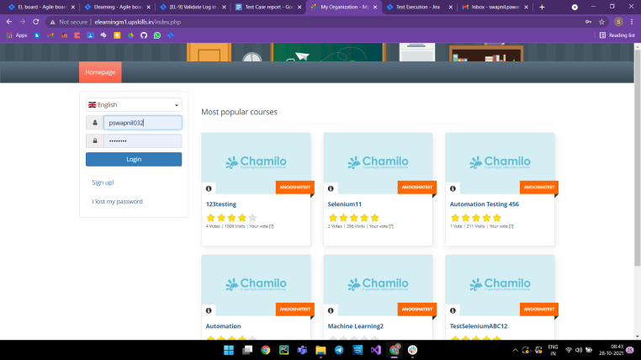

2.
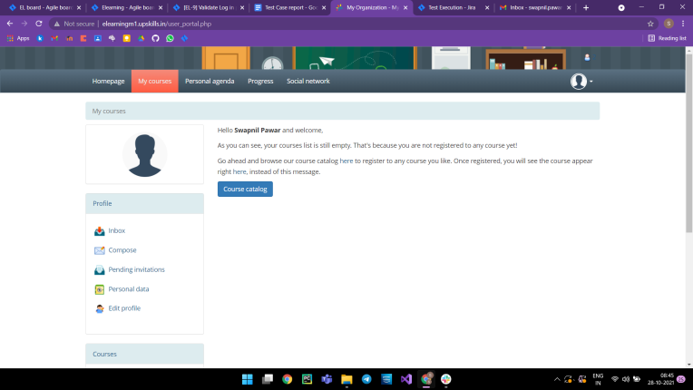

3] Test case flow for Login page-

Test Case - 02:-

Test steps :- i. I should open the login page.
ii. I should fill in the details as per test data.
iii. I should enter the login button.
Test Data :- i. Username :- swapnil7832
Ii. Password :- Demo@123
Test Result :- It should show 'Login failed - incorrect login or password.'

Snapshots :-
1.
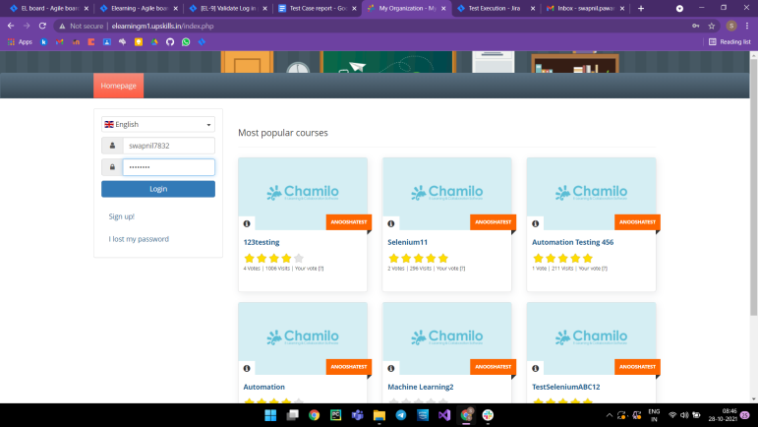

2.
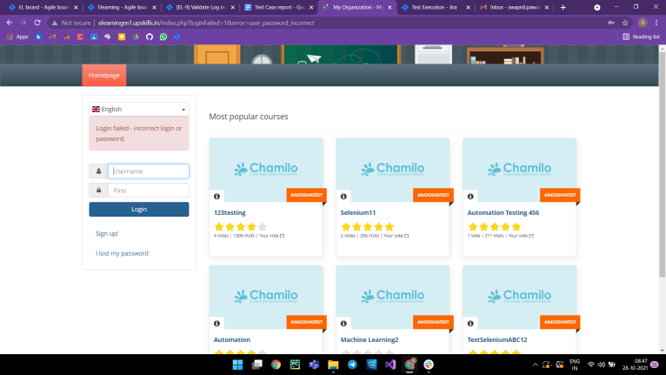

3] Test case flow for Login page-

Test Case - 03:-

Test steps :- i. I should open the login page.
ii. I should enter the login button.
Test Data :-
Test Result :- It should show 'Login failed - incorrect login or password.'

Snapshots :-
1.
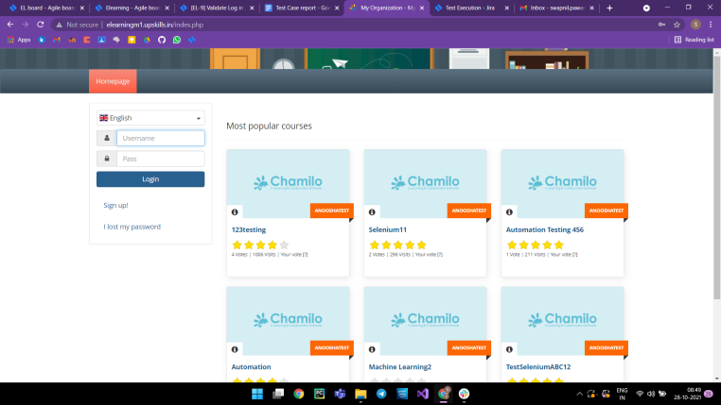
2.


3] Test case flow for Logout page-

Test Case - 01:-

Test steps :- I should click on the profile image icon and then click on logout.
Test Data :-
Test Result :- It should get back to the login page.

Snapshots :-
1.
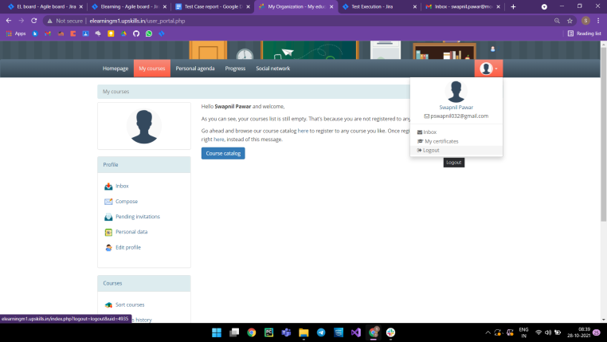

2.
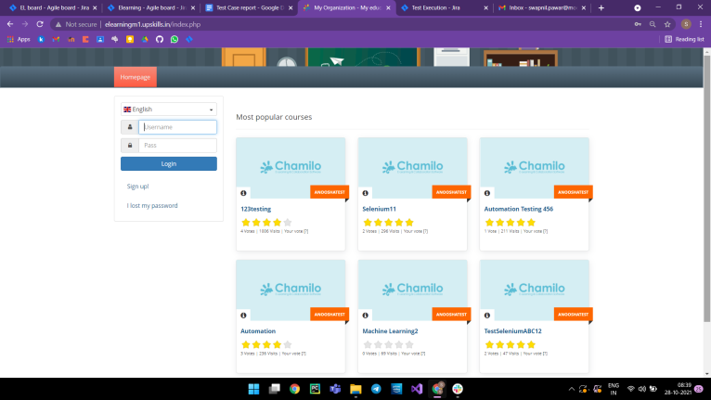

Sprint Board :-
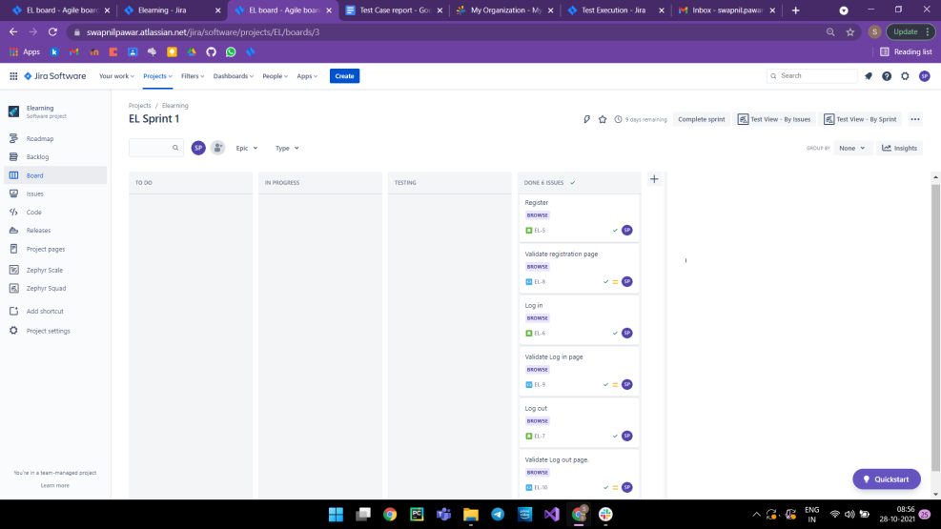

Test Summary:-
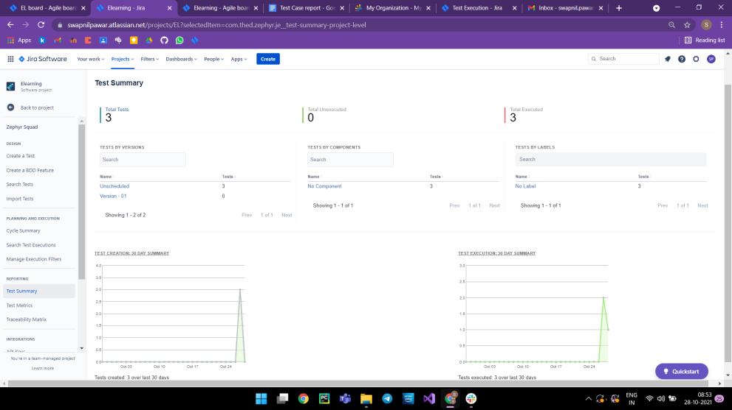

Test Matrix :-
